**INTRODUCTION**

Predicting stock market prices is a complex task and is influenced by numerous factors, including economic indicators, company performance, market sentiment, geopolitical events, and more. It's important to note that stock prices are inherently uncertain, and even sophisticated models and analysts can't accurately predict short-term movements consistently.

Several methods are used for stock market price prediction, ranging from fundamental analysis to technical analysis and machine learning algorithms. Here are some common approaches:

1. **Fundamental Analysis:** This involves analysing a company's financial statements, earnings reports, industry trends, and economic indicators. Investors using fundamental analysis aim to assess the intrinsic value of a stock to determine whether it's overvalued or undervalued.
2. **Technical Analysis:** This approach involves studying historical price charts and trading volumes to identify patterns and trends. Technical analysts use tools like moving averages, support and resistance levels, and various technical indicators to make predictions about future price movements.
3. **Sentiment Analysis**: Monitoring market sentiment through news articles, social media, and other sources can provide insights into how investors feel about a particular stock or the market as a whole.
4. **Machine Learning:** Advanced algorithms and machine learning models are increasingly being used for stock price prediction. These models can analyze vast amounts of data, identify patterns, and make predictions based on historical and real-time data. Common machine learning algorithms include decision trees, random forests, neural networks, and support vector machines.

It's essential to be cautious when using any prediction method, as the stock market is influenced by unpredictable events and can be irrational in the short term. Moreover, past performance is not always indicative of future results.

If you're interested in using machine learning for stock price prediction, you may need to gather historical data, clean and preprocess it, choose appropriate features, and train and test your model. Keep in mind that successful predictions often require a combination of various methods and a deep understanding of the market and the specific stocks in question.

Always consider the risks associated with investing in the stock market and, if needed, consult with financial professionals before making investment decisions.

**LITERATURE REVIEW**

The application of Long Short-Term Memory (LSTM) models in stock market prediction has garnered considerable attention in recent literature. LSTMs, a type of recurrent neural network (RNN), are well-suited for capturing temporal dependencies and have shown promise in time-series forecasting, making them an attractive choice for predicting stock prices.

Researchers have explored the effectiveness of LSTM models in capturing intricate patterns and nonlinear relationships within historical stock price data. The ability of LSTMs to remember and selectively focus on relevant information over varying time horizons contributes to their success in modeling the dynamic nature of financial markets.

Several studies have demonstrated the superior performance of LSTM models compared to traditional time-series forecasting methods in predicting stock prices. The adaptability of LSTMs to different market conditions and their capacity to handle large datasets make them particularly relevant for addressing the challenges posed by the stock market's inherent volatility.

However, it is crucial to acknowledge the complexities involved in stock price prediction. The efficiency of LSTM models is contingent on various factors, including the choice of hyperparameters, the quality and quantity of input features, and the characteristics of the specific financial markets under consideration. Researchers have emphasized the importance of careful model tuning and feature engineering to enhance the robustness and generalizability of LSTM-based predictions.

Moreover, some studies have explored hybrid models that combine LSTM with other techniques, such as traditional statistical methods or other machine learning algorithms, to leverage the strengths of different approaches and improve prediction accuracy.

Despite the promising results observed in many studies, it is essential to recognize the inherent uncertainties in financial markets. The unpredictable nature of market dynamics, coupled with the limitations of historical data, underscores the need for cautious interpretation of LSTM-based predictions. Ongoing research aims to further refine these models, exploring novel architectures and incorporating additional information sources to enhance their predictive capabilities in the challenging domain of stock market forecasting.

**OBJECTIVE**

The primary objective of this project is to investigate and implement Long Short-Term Memory (LSTM) models for the purpose of predicting stock market prices. The project aims to achieve the following specific goals:

* Evaluate the Effectiveness of LSTM Models: Assess the performance of LSTM models in capturing temporal dependencies and intricate patterns within historical stock price data. Compare the predictive accuracy of LSTM models with traditional time-series forecasting methods.
* Optimize Hyperparameters and Feature Selection: Explore the impact of different hyperparameters on the performance of LSTM models and identify optimal configurations. Investigate the significance of various input features and employ effective feature engineering techniques to enhance the model's ability to capture relevant market trends.
* Address Market-Specific Challenges: Recognize and address challenges associated with the dynamic and volatile nature of financial markets. Investigate how well LSTM models adapt to different market conditions and identify strategies to mitigate potential limitations.
* Compare Hybrid Models: Evaluate the potential benefits of hybrid models that combine LSTM with other forecasting techniques. Investigate whether integrating LSTM with traditional statistical methods or alternative machine learning algorithms improves overall prediction accuracy.
* Enhance Robustness and Generalizability: Develop strategies to enhance the robustness and generalizability of LSTM-based predictions. This includes investigating methods to minimize overfitting, handling missing data, and ensuring the model's adaptability to diverse market scenarios.
* Explore Novel Architectures: Investigate emerging architectures and variations of LSTM models to identify potential advancements in stock market prediction. This may involve experimenting with attention mechanisms, ensemble methods, or other innovations in neural network architectures.
* Evaluate Practical Implementation: Assess the feasibility and practicality of deploying LSTM-based stock market prediction models in real-world scenarios. Consider computational efficiency, scalability, and interpretability in the context of practical applications.
* By addressing these objectives, the project aims to contribute valuable insights into the application of LSTM models for stock market prediction, providing a foundation for informed decision-making in financial markets and potentially advancing the state-of-the-art in predictive modeling for finance.

**WORK PLAN AND METHODOLOGY**

The work plan and methodology for this project on deploying website on Azure involve a systematic approach to ensure efficient execution and achieve the desired outcomes. The following steps outline the proposed work plan and methodology:

1. **Project Definition:**
   * Clearly outline project scope and objectives.
2. **Literature Review:**
   * Review methodologies and best practices for stock market prediction.
3. **Data Collection and Preprocessing:**
   * Acquire and clean historical stock price data.
4. **Feature Engineering and Selection:**
   * Enhance model input with relevant features.
5. **Model Selection and Architecture Design:**
   * Choose and design machine learning models.
6. **Model Training and Optimization:**
   * Train models, optimize hyperparameters, and assess performance.
7. **Evaluation Metrics and Validation:**
   * Define metrics, validate using holdout or cross-validation.
8. **Deployment and Testing:**
   * Deploy the selected model and conduct real-world testing.
9. **Documentation:**
   * Document methodology, implementation details, and decisions.
10. **Review and Refinement:**
    * Regularly review progress, refine methodology based on feedback.

Throughout the project, maintain regular communication and collaboration with the project supervisor, and development team to ensure alignment with project objectives and timely progress. Review and refine the work plan and methodology as necessary based on feedback and evolving project requirements.

**IMPLEMENTATION AND TESTING**

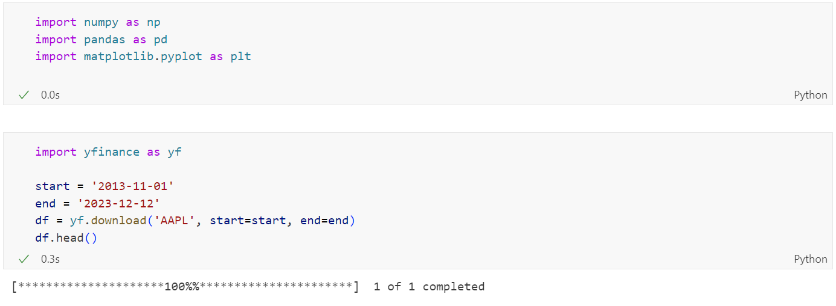

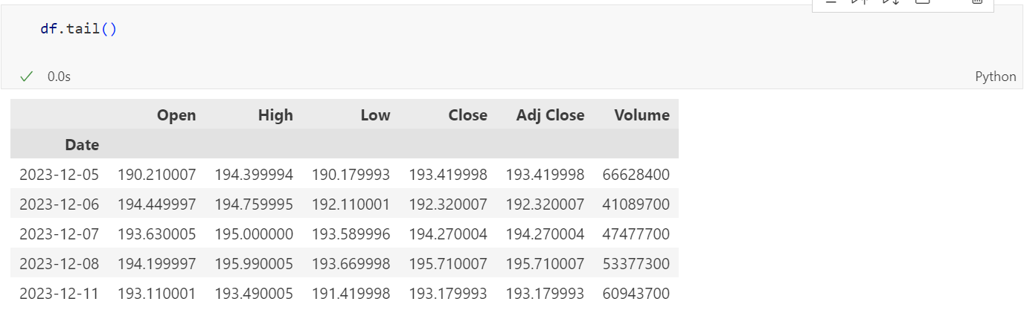

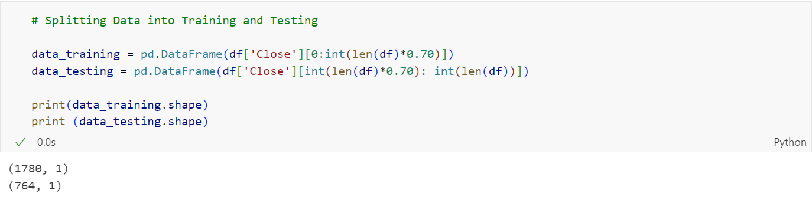

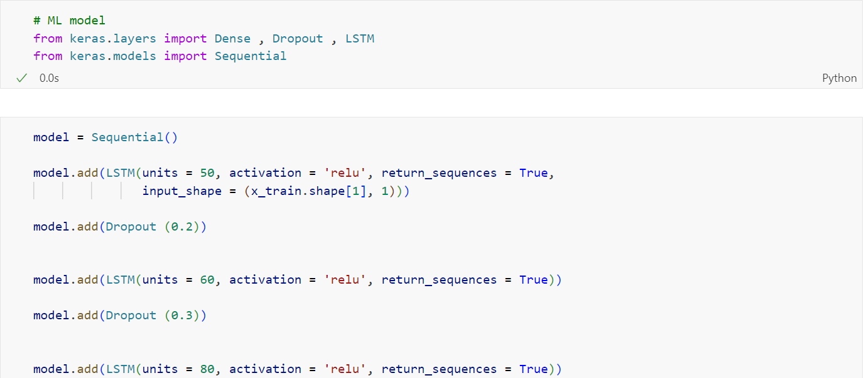

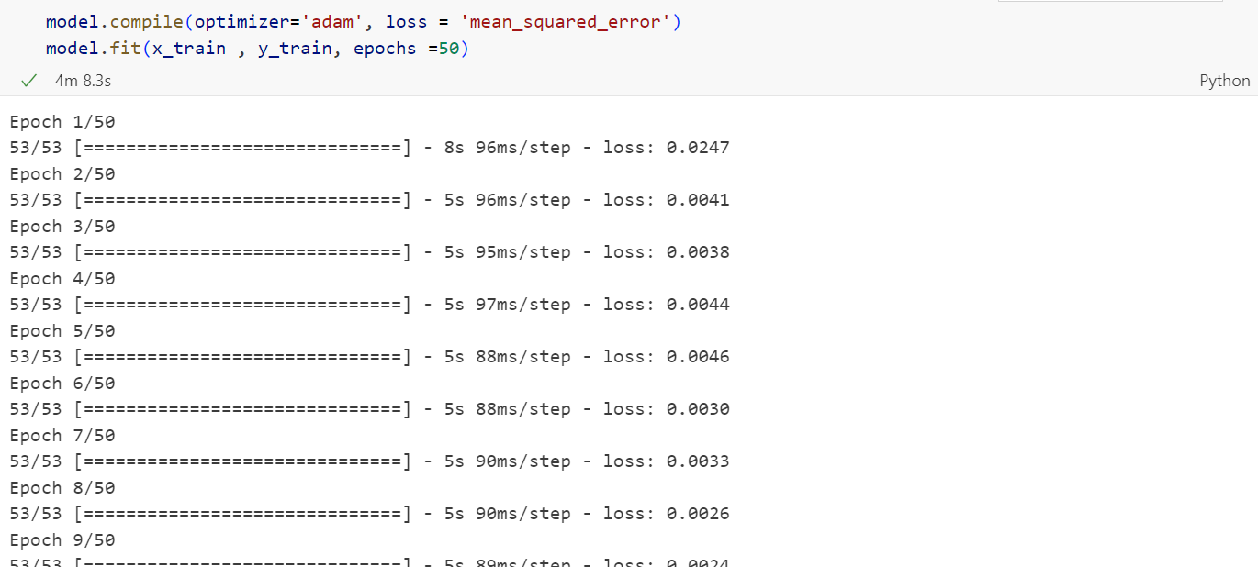

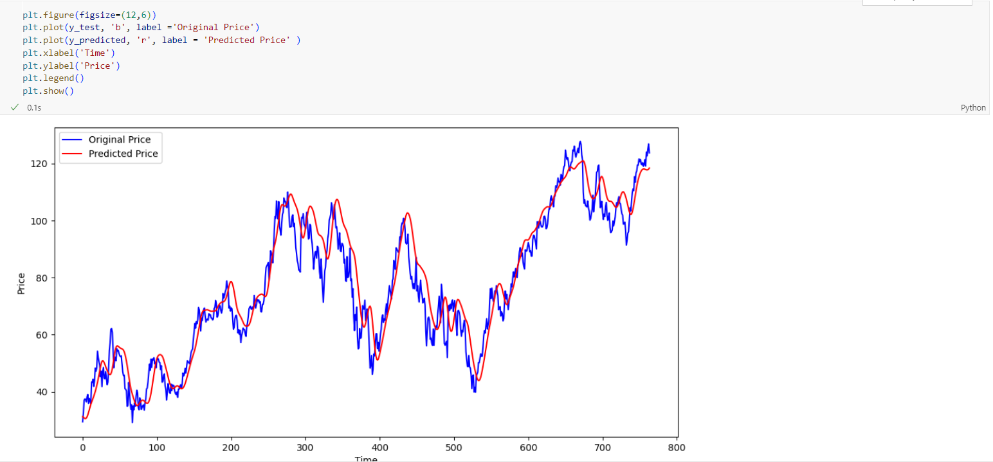

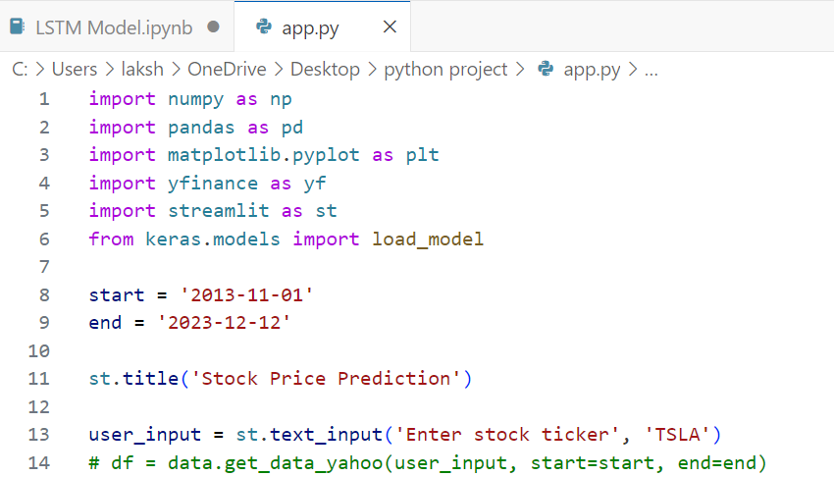

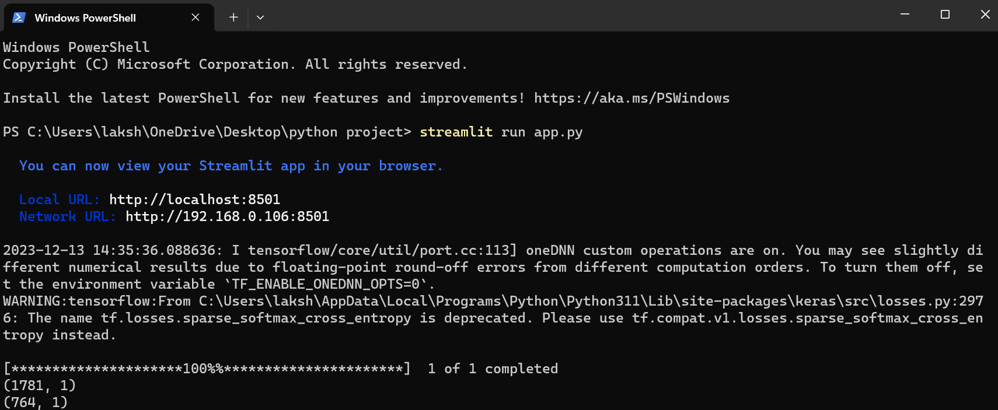

**RESULTS AND FINDINGS**

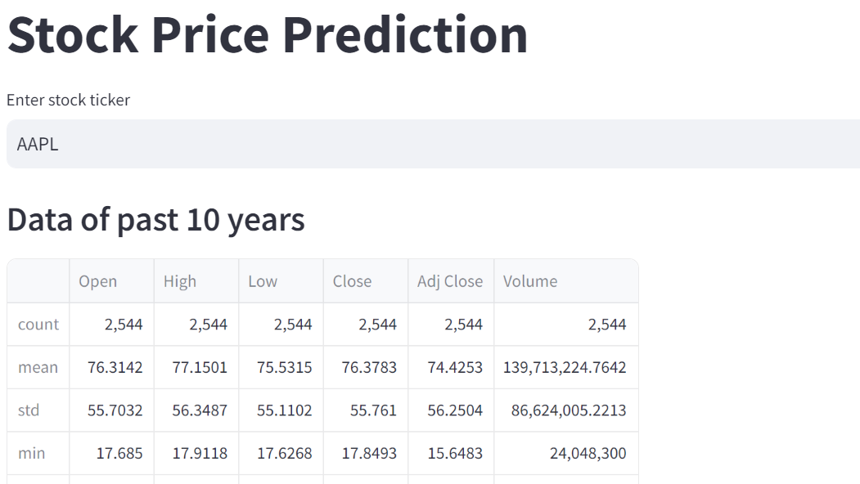

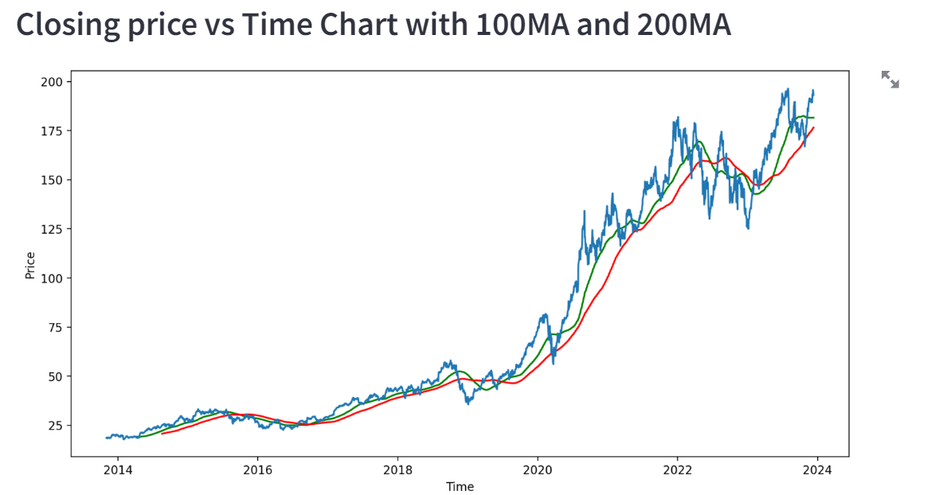

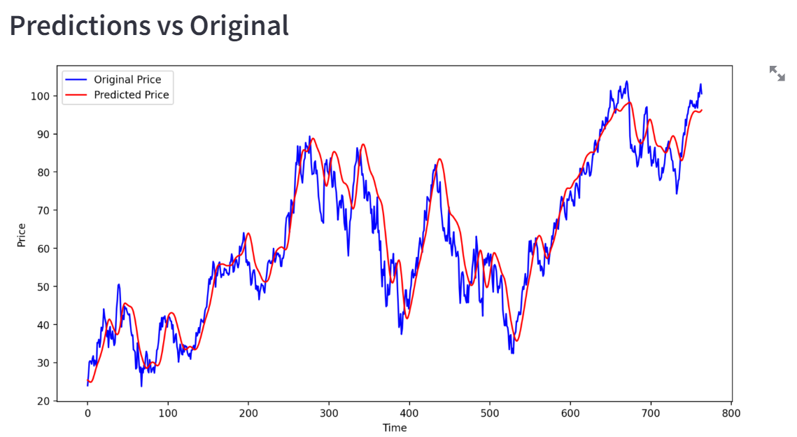

**LIMITATIONS AND FUTURE SCOPE**

Despite recent advancements, stock market prediction using machine learning still faces several limitations:

1. Data Limitations:

* Incomplete Data: Historical market data may be incomplete or inaccurate, leading to biased predictions.
* Non-Quantifiable Factors: Many factors influencing the market, such as sentiment and news events, are difficult to quantify and incorporate into models.
* Data Overfitting: Models can overfit to historical data, leading to poor performance on unseen data.

2. Model Limitations:

* Nonlinear Relationships: The stock market exhibits complex, non-linear relationships that are challenging for machine learning models to capture accurately.
* Black Swan Events: Unexpected events, like the 2008 financial crisis, can render models useless.
* Ethical Concerns: Algorithmic trading powered by machine learning algorithms can raise ethical concerns about fairness and market manipulation.

3. Computational Challenges:

* Training Data Size: Training accurate models often requires large datasets, leading to high computational costs.
* Model Complexity: Complex models with many parameters can be computationally expensive to train and optimize.
* Real-time Predictions: Predicting market movements in real-time requires efficient algorithms and hardware infrastructure.

Future Scope:

1. Advanced Data Acquisition and Preprocessing:

* Alternative Data Sources: Using social media sentiment, news analysis, and satellite imagery to supplement traditional market data.
* Data Cleaning and Feature Engineering: Developing algorithms for data cleaning, outlier detection, and feature engineering to improve model training.

2. Enhanced Model Development:

* Ensemble Methods: Combining multiple models with different strengths can lead to more robust and accurate predictions.
* Deep Learning Techniques: Exploring deep learning architectures like Long Short-Term Memory (LSTM) networks to capture complex temporal relationships.
* Transfer Learning: Leveraging knowledge from other domains like natural language processing to improve market prediction models.

3. Improved Computational Efficiency:

* Cloud-based Infrastructure: Utilizing cloud-based platforms for efficient model training and deployment.
* Hardware Optimization: Exploring hardware advancements like GPUs and specialized AI chips to accelerate computations.
* Model Compression: Developing techniques to reduce model size and complexity without compromising accuracy.

4. Ethical Considerations:

* Algorithmic Transparency: Ensuring transparency in model decisions to address concerns about fairness and explainability.
* Regulatory Frameworks: Developing regulatory frameworks to govern the development and use of AI-powered trading algorithms.

5. Human-in-the-Loop Systems:

* Collaborative Decision-making: Combining machine learning predictions with human expertise to make informed investment decisions.
* Interpretable Models: Developing models that provide clear explanations for their predictions, improving trust and confidence.

**CONCLUSION**

There are specific problems in the world that push the capabilities of data science and the technologies available in this field to their edge. Among them is the stock market prediction. It is challenging for a person to create such a model, but there are ways through which this art can be learned.

With the introduction of Machine Learning and its strong algorithms, the most recent market research and Stock Price Prediction using machine learning advancements have begun to include such approaches in analyzing stock market data.

The Opening Value of the stock, the Highest and Lowest values of that stock on the same day, as well as the Closing Value at the end of the day are all indicated for each date. Furthermore, the total volume of the stocks in the market is provided; with this information, it is up to the job of a Machine Learning Data Scientist to look at the data and develop different algorithms that may help in finding appropriate stocks values.

Predicting the stock market was a time-consuming and laborious procedure a few years or even a decade ago. However, with the application of machine learning for stock market forecasts, the procedure has become much simpler.

Machine learning not only saves time and resources but also outperforms people in terms of performance. It will always prefer to use a trained computer algorithm since it will advise you based only on facts, numbers, and data and will not factor in emotions or prejudice.

It would be interesting to incorporate sentiment analysis on news & social media regarding the stock market in general, as well as a given stock of interest.

**Key Takeaways**

* Stock Price Prediction using machine learning helps in discovering the future values of a company’s stocks and other assets.
* Predicting stock prices helps in gaining significant profits.

**REFERENCES**

1. <https://en.wikipedia.org/wiki/Stock_market_prediction>
2. <https://www.geeksforgeeks.org/long-short-term-memory-networks-explanation/>
3. <https://github.com/>
4. <https://www.geeksforgeeks.org/machine-learning/>